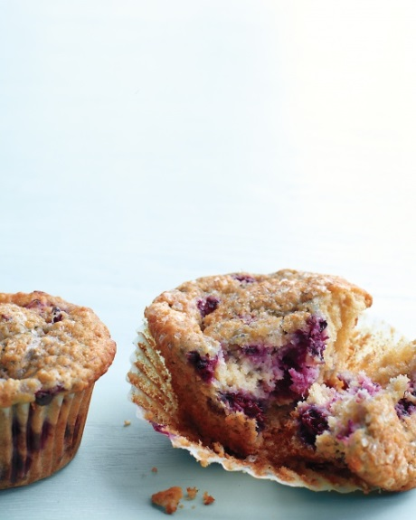
Blackberry-Oat Bran Muffins

Everyday Food, July/August July/August 2012
- Prep Time20 minutes
- Total Time45 minutes + cooling
- YieldMakes 12
Add to Shopping List

Ingredients
- 1 1/2 cups all-purpose flour (spooned and leveled)
- 2/3 cup oat bran
- 2 teaspoons baking powder
- 1/2 teaspoon baking soda
- 1/2 teaspoon ground cinnamon
- 1/4 teaspoon fine salt
- 6 tablespoons unsalted butter, room temperature
- 1/2 cup plus 1 tablespoon sugar
- 2 large eggs
- 2 teaspoons pure vanilla extract
- 1 cup buttermilk
- 1 1/2 cups chopped blackberries

Directions
- Preheat oven to 375 degrees. Line 12 standard muffin cups with paper liners. Whisk together flour, oat bran, baking powder, baking soda, cinnamon, and salt.
- In a large bowl, using a mixer, beat butter and 1/2 cup sugar on high until light and fluffy, about 6 minutes. Beat in eggs and vanilla until combined. With mixer on low, add flour mixture in 2 additions, alternating with buttermilk, and beat until combined. Fold in blackberries.
- Divide batter among muffin cups and sprinkle with remaining 1 tablespoon sugar. Bake until a toothpick inserted in center of a muffin comes out with moist crumbs attached, 20 to 25 minutes, rotating pan halfway through. Let cool in pan on a wire rack 5 minutes, then transfer muffins to rack and let cool completely.

