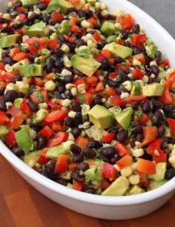
Mexican Black Bean Salad with Lime-Cilantro Vinaigrette
Serves 6-8

Ingredients:
1 15-oz EACH Black beans & Kidney beans, rinsed well and drained
1 small can of corn
1 red bell peppers, diced
2 Green onions
Sea salt, to taste
1/4 tsp cayenne pepper
2 tbsp raw, unpasteurized honey
1-2 limes juiced (add zest if you like)
1/2 cup chopped fresh cilantro
1 avocado, pitted, peeled and chopped
Optional: cubed mango /strawberries/kiwi
Directions:
1. In a large bowl, combine all ingredients except for avocados and mix well.
2. Before serving, add avocados and fruit mix gently, being careful not to mash. Garnish with additional cilantro.

