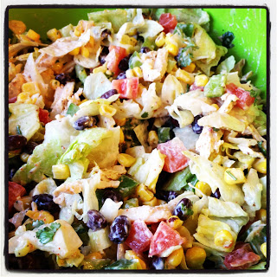
southwest chopped chicken salad
Ingredients
- 4 cups shredded chicken
- 1 green bell pepper, diced
- 1 red pepper, diced
- 1 can black beans, rinsed
- 1 can sweet yellow corn (or 1 cup frozen corn, thawed)
- 4 roma tomatoes, diced
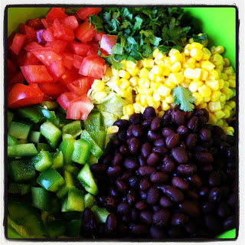
- 8 green onions, sliced
- romaine lettuce, washed and chopped
- 1/2 cup cilantro, chopped
- 2 ripe avocados, diced
- 2 cup crushed tortilla chips

Dressing:
- 1/4 cup mayonnaise
- 1 cup Greek yogurt
- 2 tbsp ranch seasoning
- 2 tbsp taco seasoning

Directions
- In a large bowl, combine all salad ingredients together, excluding the tortilla chips.
- In a small bowl stir all dressing ingredients together.
- Pour dressing over salad, starting with about half of the dressing.
- Toss to combine, then gradually add more dressing until it is dressed to your liking.
- Top with tortilla chips. Enjoy!

